Name:

Nornajmi Bin Nasuha

Quote:

You only live once so make sure the life you have is worth it

Bio:

My name is Nornajmi Bin Nasuha, I’m just a normal guy that likes to draw in class even though I’m a science student. I like to draw backgrounds and design weapons for my character. After that I’m moving to 3D style art like modelling a scene or object in maya and blender. I’m also interested in background gaming design and one of my ambitions is to be one of the artists in game companies like Square Enix and Capcom. I’m also a fan of gacha games like fate grand order, Honkai impact 3 and Honkai star rail. Other hobbies that I have is playing card game like Cardfight vanguard and Hololive Tcg.

Social media:

Instagram - @Najmiritsuka

Facebook - Nornajmi Nasuha

x - @Najmifujimaru

email: -Nurnajminasuha@gmail.com

**Description of Personal Artworks for Magazine**

1. Avatar of light and dark

My Oc with 2 characters of main monster from my card game name Cardfight Vanguard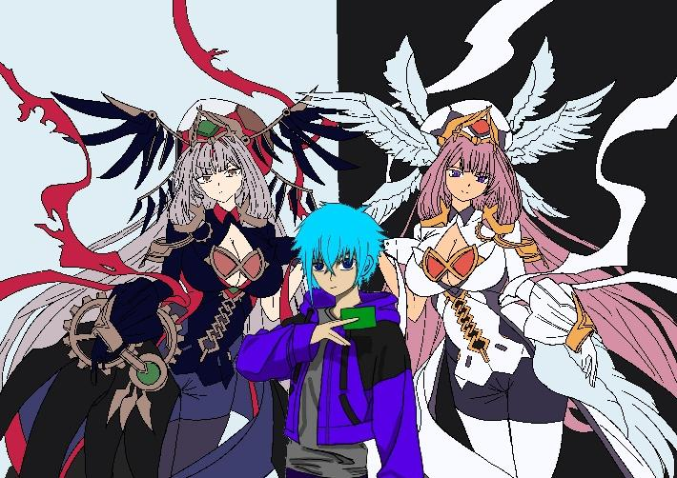

1. Chibi Oc

A chibi version of my Oc (Original character)

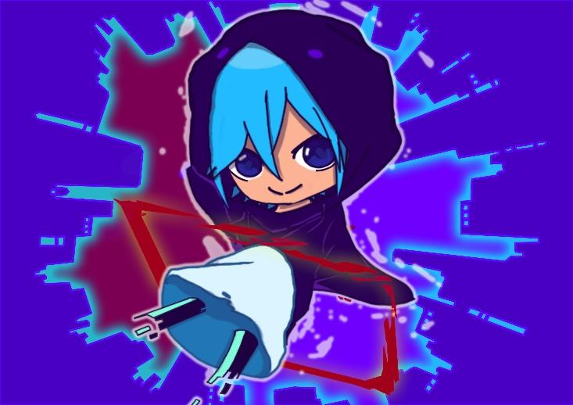

1. Nier Automata robot

Try to model a Nier automata robot in maya

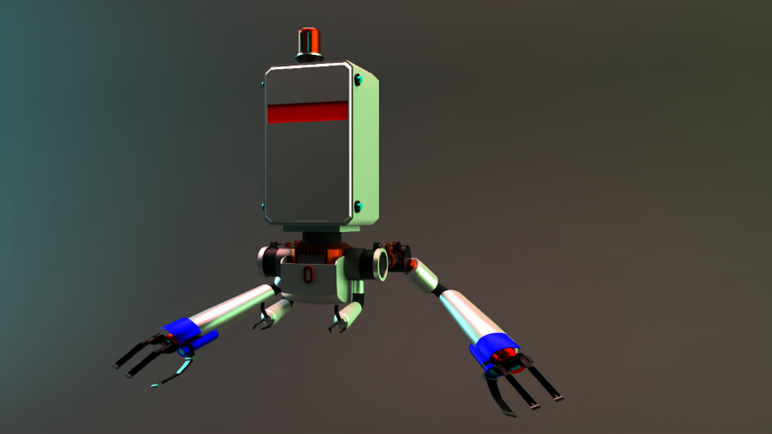

1. Assignment work

The artwork is from one of my illustration class, the assignment is batik with Asean element

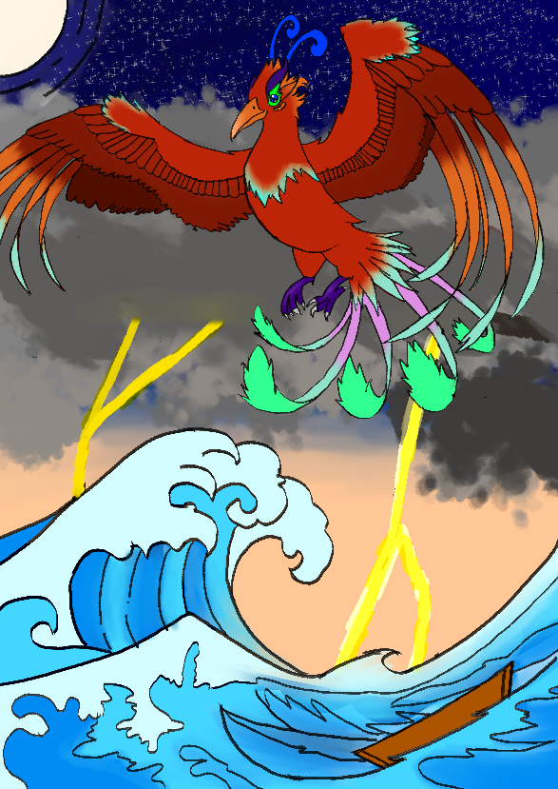

1. Illustration

Originate from my illustration class that want to symbolize childhood memories. A shop that I like to go to when I a little boy to buy candies and toys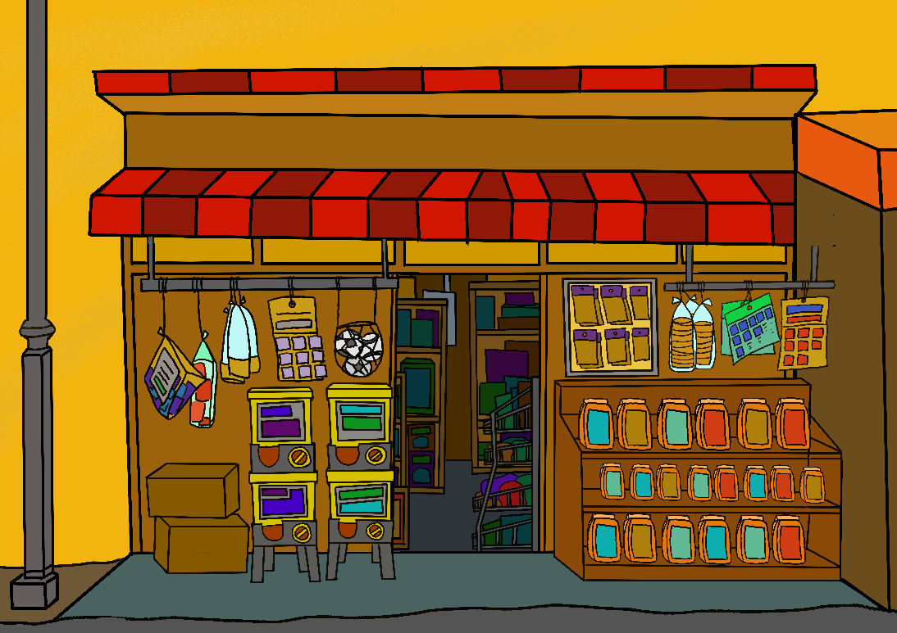\

1. Lostvayne from Seven deadly sins

Made a model of a weapon in seven deadly sins.

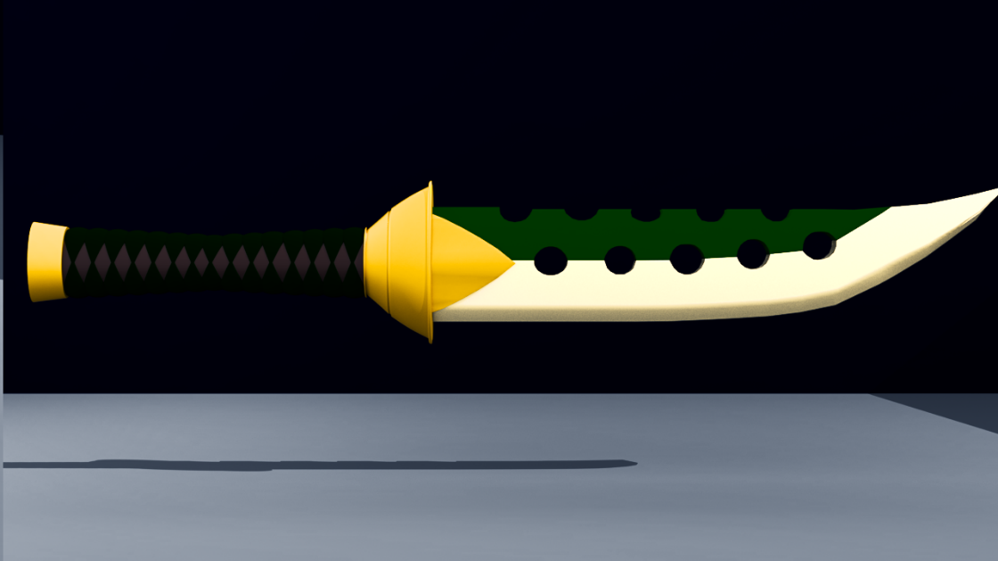

1. Nier Automata weapon

Made a model of a weapon from Nier Automata 2B main Weapon